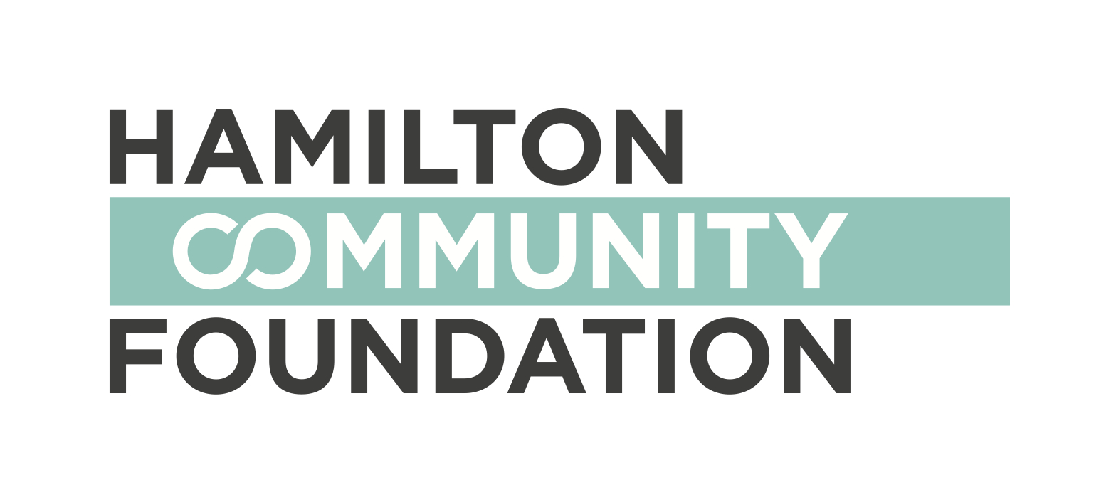
Neighbourhood Leadership Institute

PARTICIPANT APPLICATION
Application Deadline: January 16, 2015

NOTE: This is a group application. Please fill it out together with your application partner. If you require more space, please attach additional pages to your application.

Group Participant #1:

Name:

Email:

Address:

Phone

Group Participant #2:

Name:

Email

Address:

Phone

Please list the neighborhood you reside in:

Please list the neighborhood your idea applies to:

What makes you passionate about the neighbourhood in Hamilton you are engaged in?

Describe your idea and/or project that you will be working on if accepted into the NLI. Please indicate the status of your project in terms of its development. (Example: I bring small groups of neighborhood kids together to learn about mediation. The issue of youth violence is important to me because of the escalating violence between children with little positive parental guidance in my neighborhood. I have been involved with this project for the past two years, and am planning to expand the project to reach more children.)

Why do you think the NLI is a good place to help you grow your idea?

What does leadership mean to you?

Please list three leadership qualities you admire:

Please list two areas you hope to grow your skills through your involvement in the NLI.

How did you become aware of the NLI?

How can we get in touch with your reference? Either attach a written reference with your application, or provide contact details here.

The Neighbourhood Leadership Institute (NLI) is a joint initiative by the Hamilton Community Foundation and the City of Hamilton’s Neighbourhood Development Strategy.

Neighbourhood Leadership Institute

PARTICIPANT APPLICATION GUIDELINES
Deadline: January 16, 2015

Do you have an idea that will benefit your neighbourhood?

Would you like to develop the skills that can help you move your idea forward?

Starting in February 2015 the Neighbourhood Leadership Institute will offer 10 leadership training sessions open to residents in neighbourhoods across Hamilton. Sessions will run on Saturdays. Training is free. It is available to local residents who are dedicated to working with others to make change in their community.

Throughout the training, you will:

- Develop your leadership skills in areas such as: project management, conflict resolution, communication, grant writing, public speaking, working with others, self-advocacy, leading teams

- Grow your skills and talents by working with others to manage the development of your idea into a project you can later put into action in your neighbourhood

- Share what you learn as a way to build new connections to support your community work, and employment/educational goals

- Explore Hamilton and the work of other neighbourhoods in the city

By the end of the training, you will:

- Develop your idea into a fully formed project plan that can be applied in your neighbourhood

- Become eligible to apply for up to a $500 small grant to support your project

- Be eligible for a college-level course credit

- Complete a portfolio that tracks what you learned and your accomplishments, as well as help you set goals and reflect on where you want to go next

To apply, you must:

- Be an adult who either has been engaged, is currently engaged or just started to be engaged in your neighbourhood

- Submit an application with one other person who supports the project idea and wants to work with you on it

- Provide at least one reference from a community partner, service provider, Community Developer or Neighbourhood Planning Team Executive member who supports your project idea

- Be able to commit to attending at least eight of the 10 learning sessions on Saturdays, starting at the end of February (lunch, transportation and childcare will be provided). Sessions will run from 10 a.m. to 3 p.m.

Application Instructions

Complete the application form. If you have questions or are not sure who to partner with, please contact the Community Developer in your neighbourhood, your Ward councilor or Sarah Glen, NLI Coordinator. We are here to help!

Applications are posted at: www.hamiltoncommunityfoundation.ca
Completed application forms should be delivered to the Hamilton Community Foundation office located at:
Hamilton Community Foundation
120 King Street West, Suite 700
Hamilton, Ontario L8P 4V2
Applications must be received by January 16, 2015.

Evaluation Criteria:

Applications will be evaluated based on:

- A demonstrated degree of dedication to supporting Hamilton’s neighborhoods
- A clear indication of passion for an existing community project or idea
- A willingness to learn and an openness to further developing leadership skills

If you have any questions, please contact Sarah Glen at nli@hamiltoncommunityfoundation.ca

The Neighbourhood Leadership Institute (NLI) is a joint initiative by the Hamilton Community Foundation and the City of Hamilton’s Neighbourhood Development Strategy.

