OFFICE USE (completed by organizer) |  |  | 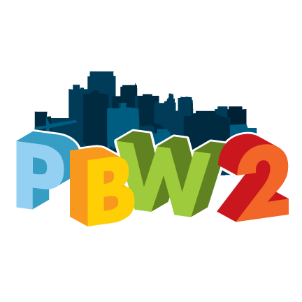  29052013-2
Ref. #: | Assembly: | Initials:

PROJECT SUBMISSION FORM (page 1 of 3)

Name: | Sandy Skrzypczyk
Phone: | 905.521.0012 | Email: | sandy.skrzypczyk@gmail.com

Project: | Neighbourhood Signage
Location: | Within all six Ward 2 neighbourhoods (e.g., the four corners of a neighbourhood boundary street; above street tab signs with historically significant areas within a neighbourhood)
Purpose: | Tell us a bit about the project. Does it help solve a particular problem or need? How will it improve life in Ward 2?  The concept of neighbourhood signage was mentioned at many of the idea meetings, including community I.D. signs, street/avenue signs, and welcome signs. Given the similarity of these ideas, this proposal is asking for a lump sum of monies that could be divided between all six Ward 2 neighbourhoods, who would then decide what kind of signage they would like. See next section for suggested amount of funds per neighbourhood.  Many of Ward 2 neighbourhoods are often portrayed in a negative way, and the Neighbourhood Associations and other residents/business owners are actively working to improve this image. Neighbourhood signage contributes to increased neighbourhood pride and identity, especially if historical and cultural icons are incorporated into the signs. For example, the shamrock is often mentioned because it is symbolic of the Corktown neighbourhood.
Scope: | What information is required to make this project happen? For example, land, machinery, materials, etc. If there is any work, will it be done by volunteers or by city staff?  Idea generators, Neighbourhood Association members, and/or interested residents would be responsible for working with city staff on the wording, design, and placement of the signs. Staff input is needed as they would have the knowledge of what is feasible re: placement, etc (Sue Russel, PW, Glen Norton, PED).  Examples of existing signs that illustrate what is being requested include (See pg. 3 for pictures)  - Welcome to the North End large free-standing signs at major entrances into the neighbourhood (Welcome signs are desired, but many said that these temporary signs are not attractive and would not want theirs to look like these ones)  - Jamesville - Corso Racalmuto sign above Murray Street tab sign on street poles  - Neighbourhood I.D. banner signs  Materials required would be dependent on the final design, placement, and number of the signs per neighbourhood. Basic street tab signs & metal banners most likely can be fabricated in-house; whereas, more elaborate signs may require outsourcing. Other than the initial planning and implementation of this project, minimal ongoing maintenance required.  I was unable to get feedback from staff regarding cost of neighbourhood signage, other than a discussion with Steve Molloy (PW), who was very helpful. The Welcome signs in the North End are temporary; therefore, their cost is not useful; however, apparently there are monies set aside for permanent signs. Street tab signs may be approximately $100-200 per sign. Banners may be approximately $500-1,000.  Staff will have to confirm what actually costs are for this project, keeping in mind that sufficient funds are needed to ensure this project has the desired impact that residents are looking for (e.g., $20,000 - $30,000 or $3,000 - 5,000 per neighbourhood?)

Please check the boxes that apply:

Physical Infrastructure: | Effects on Societal Living Conditions:
☐ Water  ☐ Roads and Traffic  ☐ Streets and Sidewalks  X Signage (PED?)  ☐ Parks and Rec. / Open Spaces  ☐ Public Transit  ☐ Forestry and Gardens  ☐ Waste (refuse and recycling)  ☐ Energy  X Other: PW – Traffic Operations & Engineering Services | X Enables  X Enhances  X Sustains  ☐ Other – explain:

Signature: |  | Date Submitted:
NOTES (page 2 of 3)
Please include any additional details that demonstrate the value of the project.

Examples of neighbourhood street signage to convey the historical/cultural significance of a neighbourhood, and messaging welcoming people, but also to drive safely - an important issue because it is a “neighbourhood”

Street Tab Sign
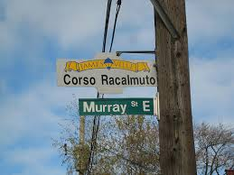

Banner Sign
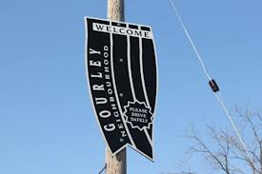

Name: | Project: |  | Initials:
NOTES (page 3 of 3)
Please include any additional details that demonstrate the value of the project.
Name: | Project: |  | Initials:

